**Text Searcher**

1. **Structure:**
2. **Classes:**

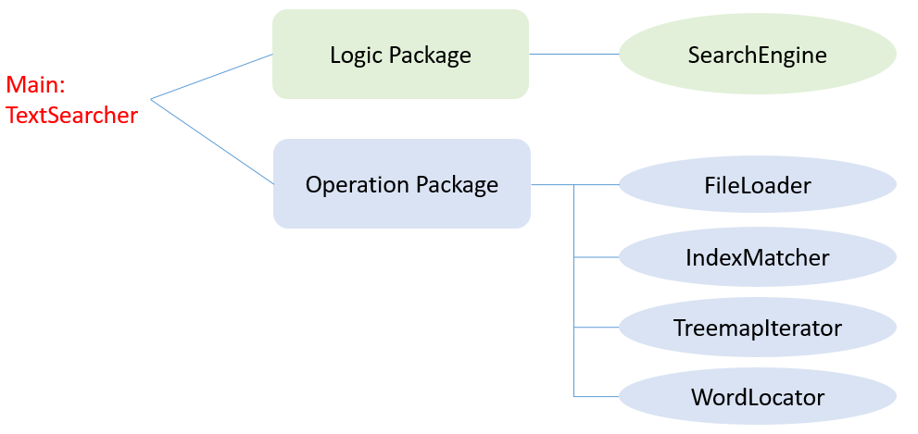

1. **Structure:**

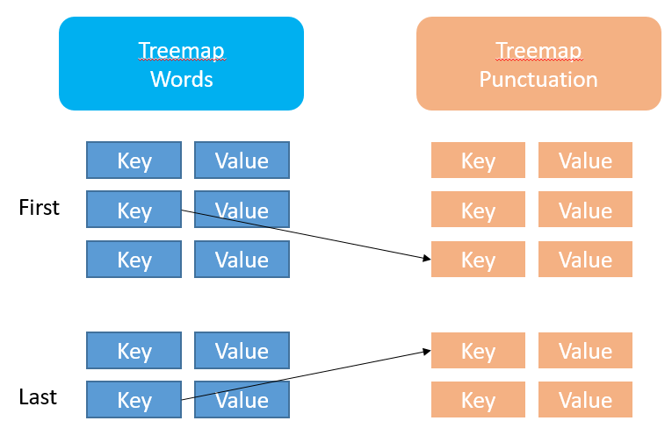

1. **Validation:**

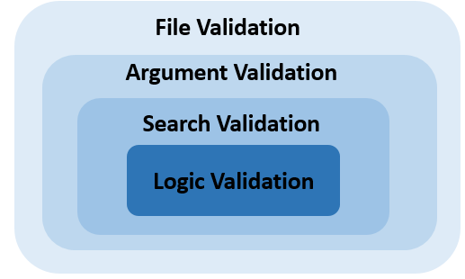

1. **Argument configuration in Netbean:**

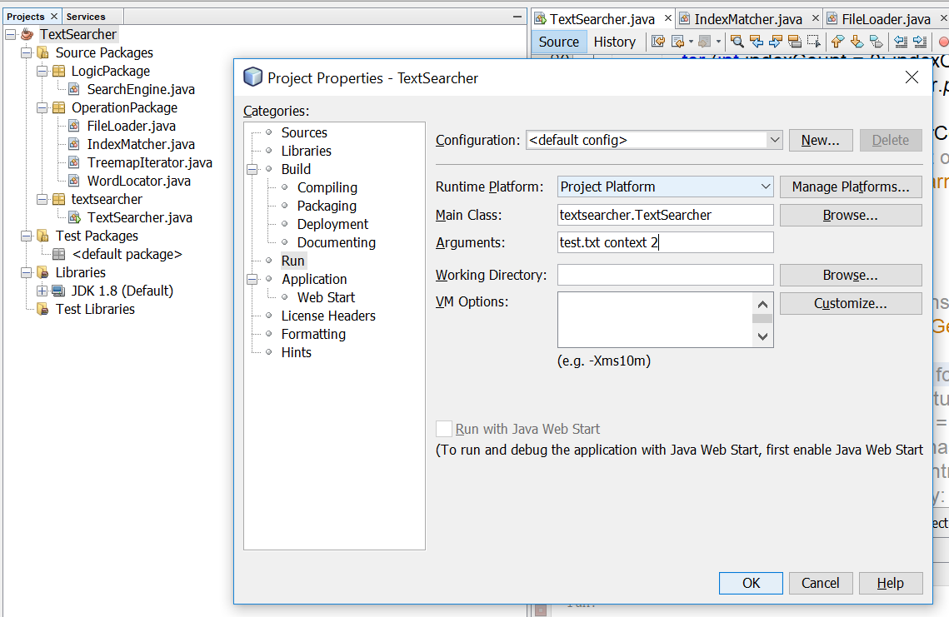

1. **File Validation: If the file exists?**

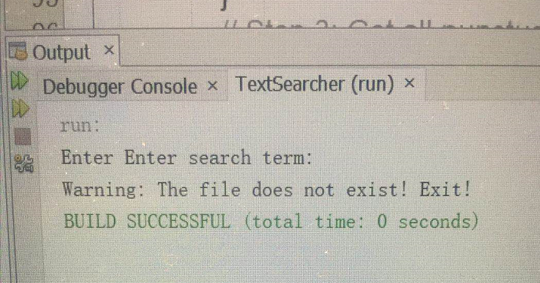

1. **Argument Validation: If the argument is valid?**
2. **Null argument;**

(All arguments must be filled:

File name(String), term for searching(String), number of surrounding context words(int))

e.g.: <Null arguments>

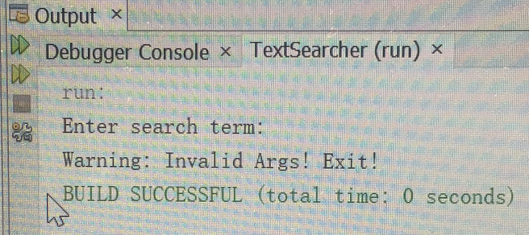

e.g: test.txt context

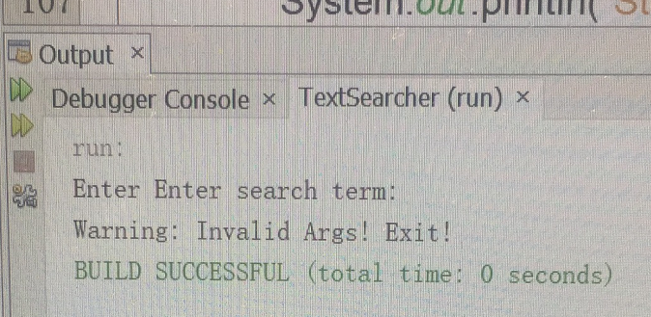

1. **Negative argument;**

e.g.: test.txt context -2

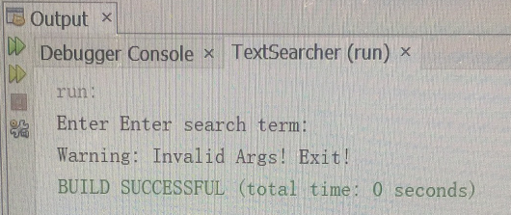

1. **Argument out of range;**

e.g.: test.txt context 1000

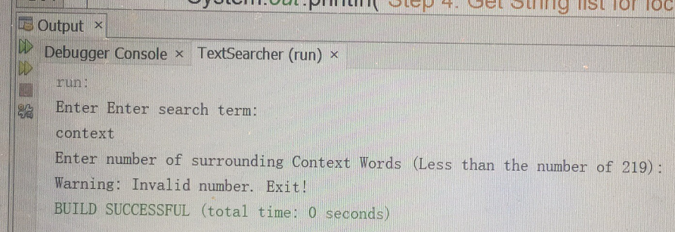

1. **If the argument of ‘Number of Surrounding context number’ is a number:**

e.g.: test.txt utility a



1. **Search Validation: If the word exists in the file?**

e.g.: test.txt hello 3

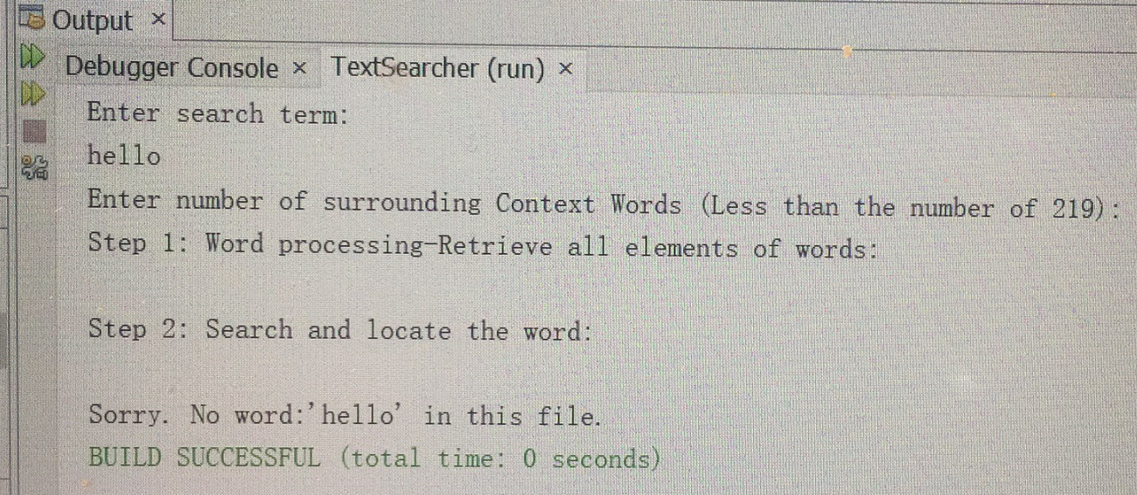

1. **Logic Validation: The calculated range is out of valid range:**

e.g.: test.txt utility 5

(The test.txt file contains 219 words, and index of word ‘utility’ is 3.

If the number of surrounding word is 5, that means the ideal index located word is:

3-5=-2. (It is invalid as it has been out of range!))

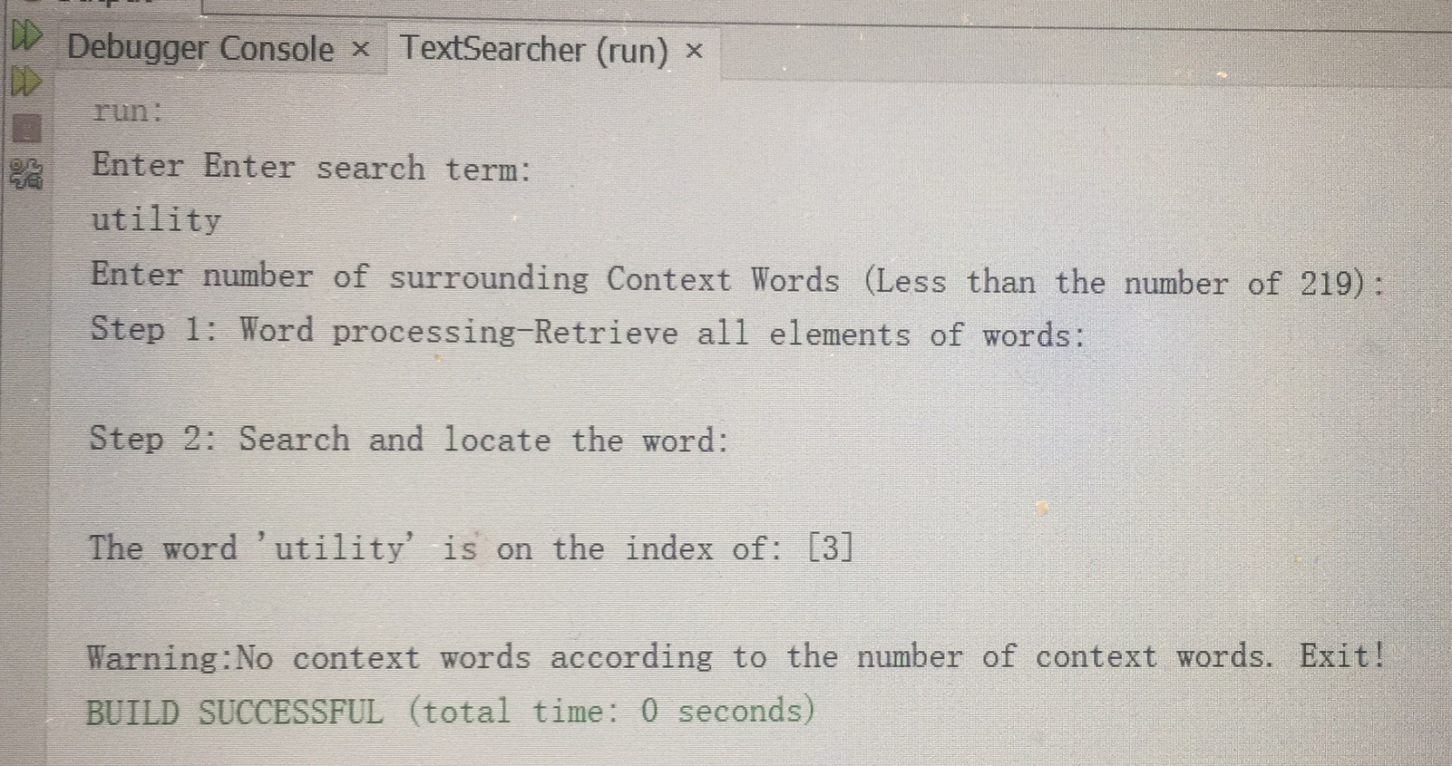

e.g.: test.txt library 5

(Same as counting from the rear:

It is invalid to count, because it will be out of the boundary of rear.)

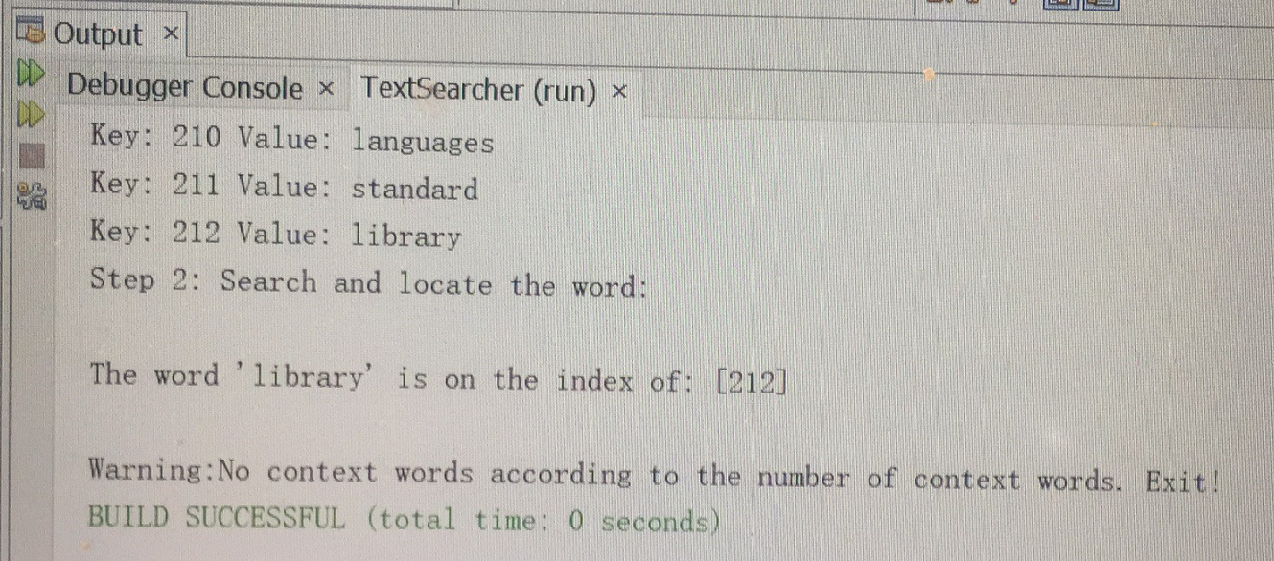

1. **Result:**
2. e.g.: test.txt context 2

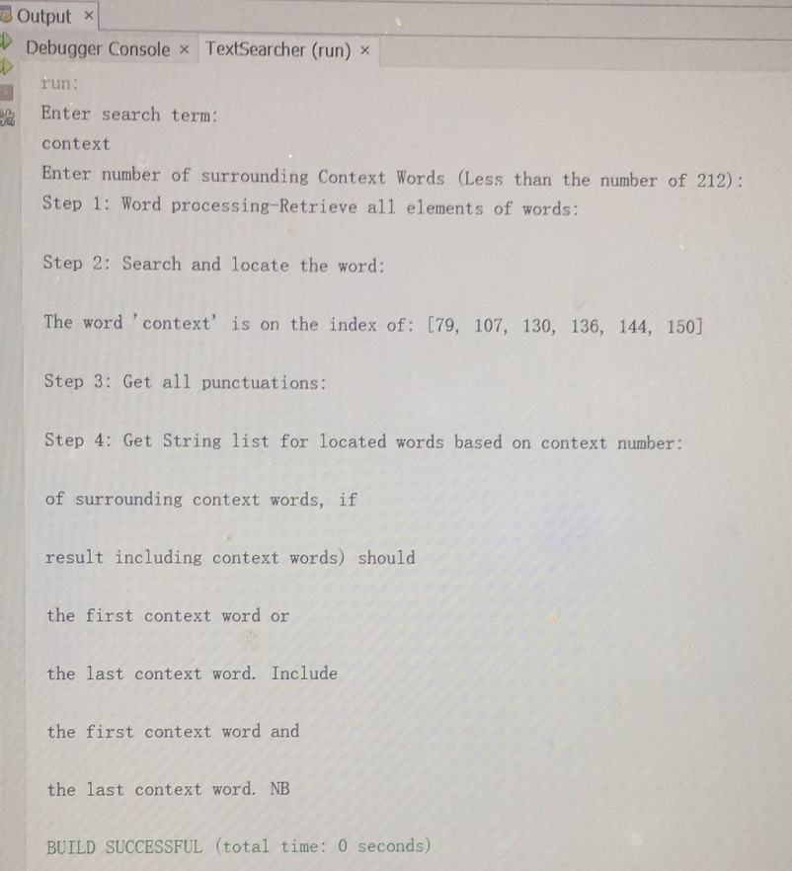

1. e.g.: test.txt available 1

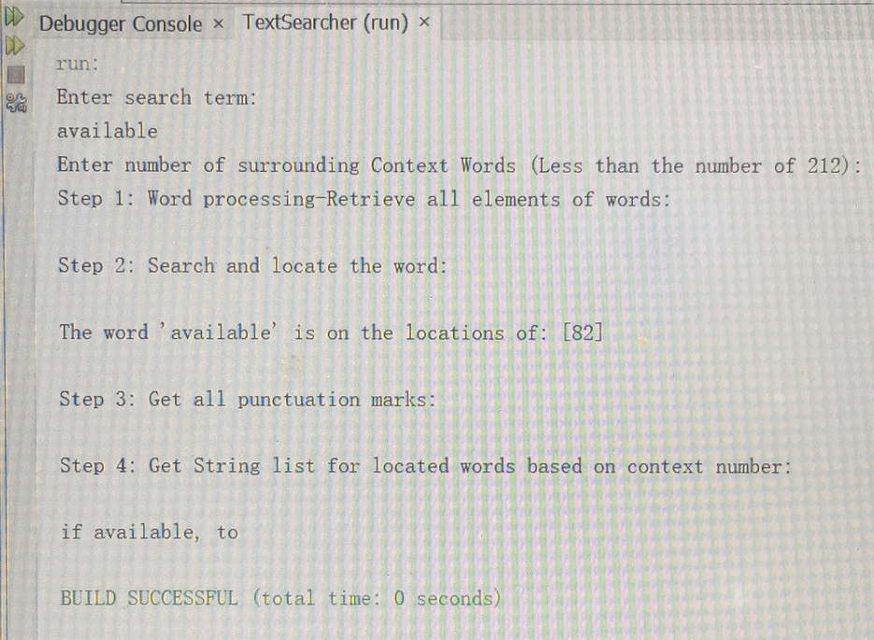

(3) e.g.: test.txt last 2

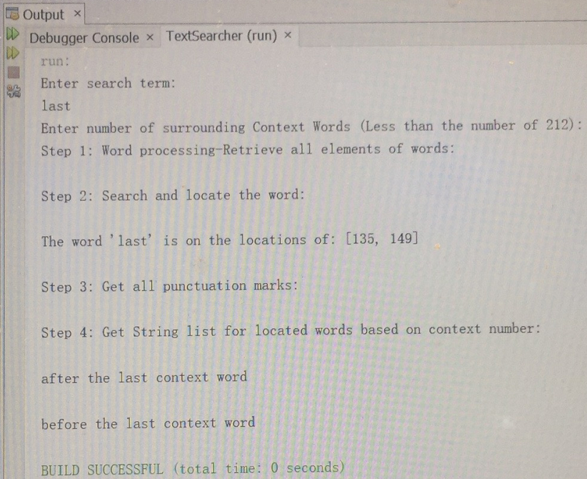

**(3) Data Structure:**

**Treemap:**

Treemap main advantage is that it allows to store the key-value mappings in a sorted order. Treemap internally uses red black tree.

This implementation provides guaranteed **log(n)** time cost for the containsKey, get, put and remove operations.

Therefore, I choose Treemap to search word and match punctuation marks.